**On March 26-27, the U.S. Supreme Court will consider two cases that are fundamentally about whether lesbian, gay, bisexual, and transgender (LGBT) Americans should have the same freedoms as everyone else. Those two cases will decide the constitutionality of the Defense of Marriage Act (DOMA) and Proposition 8 — this is a huge and historic moment! Lend your voice to the rising tide of those speaking out in favor of marriage equality.**

**[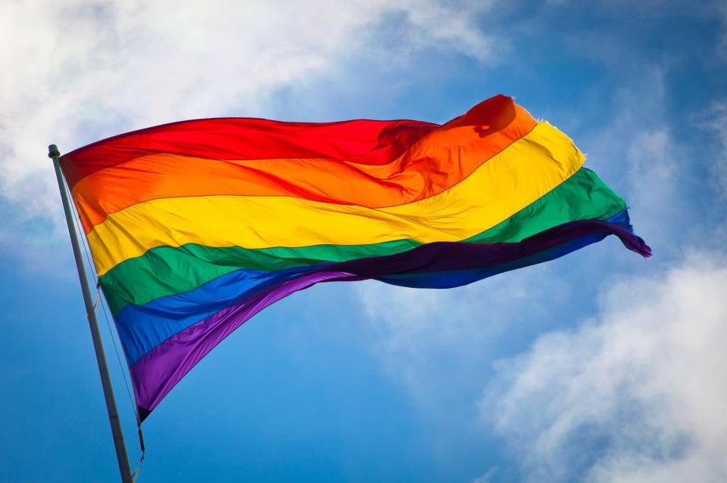](http://www.facebook.com/photo.php?fbid=10151522075886967&set=oa.621207021239043&type=1)MARRIAGE EQUALITY RALLY (Connecticut)**

**March 25th 6:00pm – 8:00pm**

**At the Federal Courthouse**

**450 Main Street Hartford CT**

**½ mile Community March to rally from Metropolitan Community Church**

**gathers at 5:30pm, 155 Wyllys Street**

**Wear Red & Bring Signs**

**For more info visit FaceBook *Marriage Equality Rally (Connecticut)***

**or @** <http://www.lighttojustice.org/index.html>